

**October 22, 2015 Library 407, 10:00AM**

1. Call to Order
2. Executive Committee Reports
   1. President, Amanda Green
   2. Vice-President, David Lambour
   3. Treasurer, Tiffany Soublet
   4. Corresponding Secretary, Brian McDonald
   5. Recording Secretary, William Guillory
3. Committee Reports **(Call for Members)**
   1. Staff Concerns Committee
   2. Events Committee
   3. Awards Committee
   4. Membership/Elections Committee
4. New Business
5. Old Business
6. Guest Speaker:
7. Next Meeting – November 19, 2015
8. Adjournment

Staff Council Meeting Minutes

Thursday, October 22, 2015

Library 407, 10:00AM

|  |  |  |
| --- | --- | --- |
| Councilors | Members | Guests |
|  |  |  |
| Amanda Green | Suzy Calamari | Pierre Champagne |
| David Lambour | Marilyn Hayden |  |
| Tiffany Soublet | Jan Hooks |  |
| William Guillory | David Richardson |  |
| Linda Miller | Sherri Ganucheau |  |
| Norma Mukherjee |  |  |
| LeAnne Sipe |  |  |
| Carol Lunn |  |  |
| Marie Kaposchyn |  |  |

**Guest Speakers:**

Sherri Ganucheau, Risk Management Coordinator

David Richardson, Department of Health & Safety

The meeting was called to order at 10:08am by the SC President Amanda Green.

Approval of the September meeting minutes will be postponed until the next meeting (11/19/15).

**EXECUTIVE COMMITTEE REPORTS**

Report by the President

Announcements:

* Our Corresponding Secretary, Brian McDonald is a new father!!
* The Health Benefits Fair Recap
* Submit Questions/Comments to the Staff Council Suggestion Box or Online
* Search Committee for new UNO President has been formed
* University Budget Review Committee (next meeting 10/26/2015)
* Deadline for Mandatory Staff Training (11/1/15)
* Friends of the Library Books Sale (11/3 and 11/4/2015)
* Deadline for Health Benefits changes (11/13/2015)

**UNO Presidential Search**

Dr. Sandra Woodley, president of the University of Louisiana System, has been in contact with SC President Amanda Green concerning the interim President and pending job search for the new President at UNO. Dr. Woodley is a non-voting member of the search team.

Witt/Kieffer is conducting the search.

The voting members of the search committee include UL Board Members: James Carter, Edward Crawford, Pamela Egan, E. Gerald Herbert, Jimmie Martin, Mark Romero, Robert Shreve, Winfred Sibille, Gary Solomon, and UNO Faculty Senate President Cherie Courseault Trumbach.

The non-voting advisory committee includes: Joy Ballard, Jim Tucker, Al Herrera, Russell Trahan, Barry LeBlanc and Dr. Woodley, serving as chair.

Dr. Randy Moffett has been recommended to become our interim President.

The search process will begin after Dr. Moffett’s temporary appointment is approved and an institutional review process is scheduled to occur immediately after he takes charge to assess the University’s overall standing.

While being assured the process of search and selection would be arbitrary and transparent, there was a mood amongst the Council that we ought to research selections in the UL System, historically and procedurally. President Amanda Green indicated that she had already browsed a number websites at other institutions as she probed into this concern.

Since Dr. Woodley has already spoken to the Faculty Senate, it seemed only logical for the Staff Council to request a visit and explanation as well. In conducting her research President Amanda Green noted that the UNO Staff Council is a rather unique body and there do not seem to be similar bodies on other UL System campuses. Dr. Woodley has expressed interest in meeting with the UNO Staff Council to address our questions and concerns.

The search committee will hold an open forum on November 9 at 11am.

The UL System has a dedicated web page for the search and the link is on the UNO Web Page.

**The University Budget Review Committee**

The University Budget Review Committee (UBRC) will meet every two weeks. The initial goal is to increase information sharing throughout the University.

The UBRC will offer advice regarding the budget to the President and disseminate information about the budget to the respective constituencies.

Current tasks for the UBRC include reviewing budget requests and any modifications as well as drawing up recommendations regarding policies on vacant positions, sabbaticals, salary adjustments, and contingency funding.

The UBRC will receive copies of quarterly financial reports that are submitted to the UL System, projected revenues and expenditures in October and April of each year, explanations of variances in revenue and expenditures on a quarterly basis, and other information as requested.

The UBRC has met twice this semester. The current budget for UNO is $101.2 million and the Board of Regents has warned all universities to prepare for a mid-year budget cut. UNO’s President Fos is projecting an amount of $7 million in addition to the current $1 million deficit.

SC President Amanda Green is pushing for the addition of one additional member to match the number of representatives the Faculty Senate has on the UBRC.

**Report by the Vice President**

Vice President David Lambour began with remarks about the President’s search, first noting the firm that has been enlisted and the discussion that ensued when representatives from Witt/Kiefer met with the Faculty Senate. A tentative timeline was established and a general announcement for the position was published in the media. An open forum for the University community is scheduled to be held on November 9 at 11am.

A suggestion to move the January 2016 meeting start time to the afternoon was entertained and a discussion led to the consensus that it would be a good idea to try. Mr. Lambour further suggested that we use this meeting to “bring along a friend”, to increase attendance at the SC meetings.

A discussion about salary issues started when Mr. Lambour noted that he had gained access to a financial document containing alleged increases for more than sixty people. Several members of the Council expressed their frustrations in hiring/keeping reliable personnel as cost cutting and departmental reorganizations. Ms. Soublet offered input and stated she would follow up on this matter, as several members of the Council were concerned with equity and transparency.

**Report by the Treasurer**



**Discussion**

During a pause in the agenda proceedings, Jane Hooks made several comments. She would like to see the SC link elevated on the School’s homepage. She suggested the SC make an effort to contact retired staff council to generate an interest in on campus issues and to support the main event in the Spring.

At this point we returned to the agenda and turned over the floor to the guest speakers.

**Guest Speakers:**

**Sherri Ganucheau, Risk Management Coordinator**

**David Richardson, Department of Health & Safety**

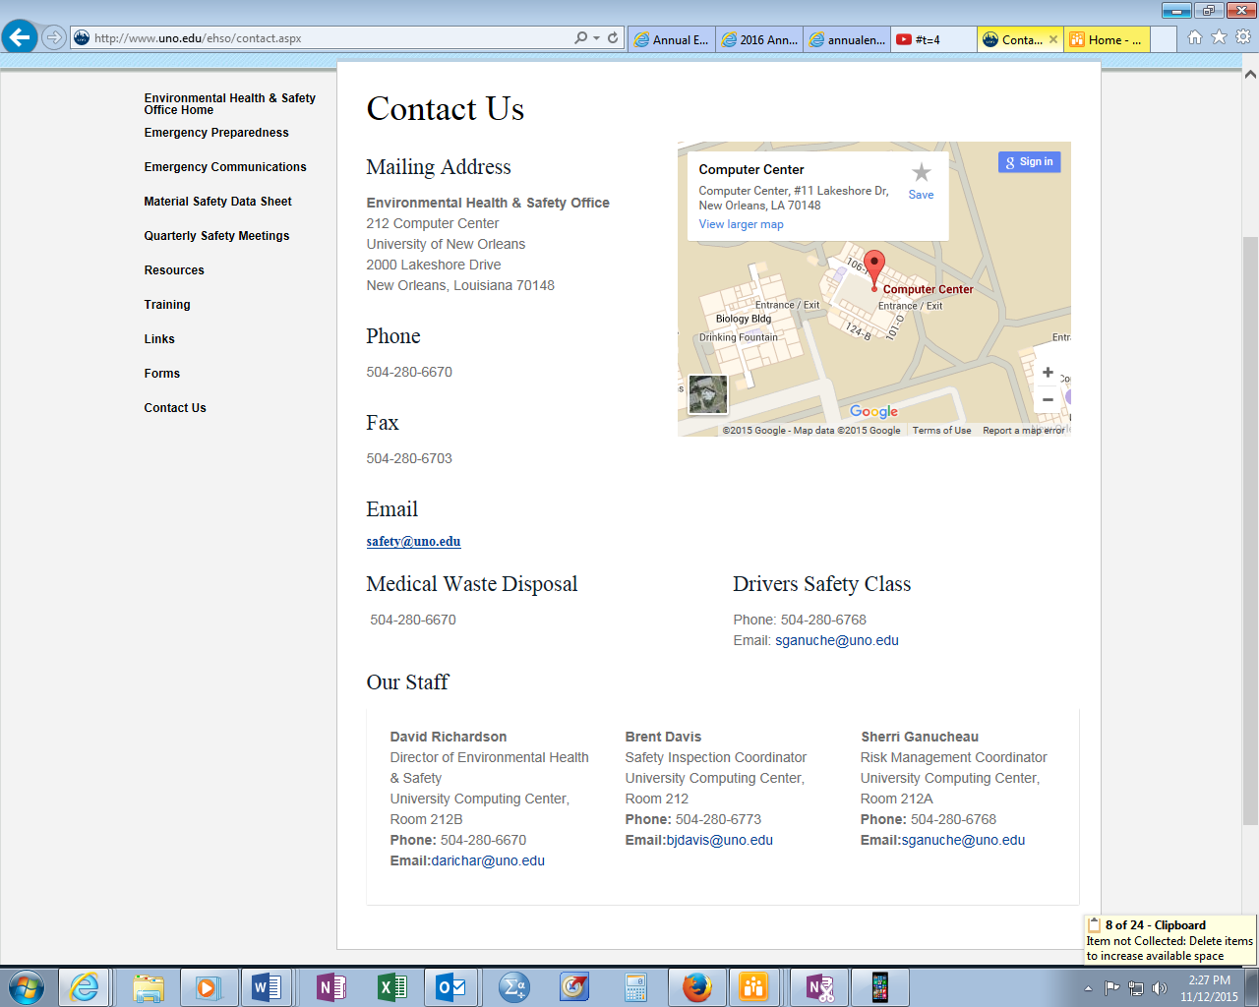

Mr. Richardson and Ms. Ganucheau discussed the wide range of services they provide through the Office of Environmental Health and Safety. The screen shot of their website above provides a list of those services, where their office is located on campus and their contact information.

The UNO Web link is :

<http://www.uno.edu/ehso/contact.aspx>

A move to adjourn was entertained, seconded and approved.

The Staff Council adjourned at 11:30 am.

Next meeting is scheduled for November 19th at 10am.

/wag

20151105