Default Report
Employer Satisfaction Survey (2018-2019)
January 7th 2021, 11:10 am CST
Q1 - How prepared were the UNO graduates in their ability to set instructional outcomes?
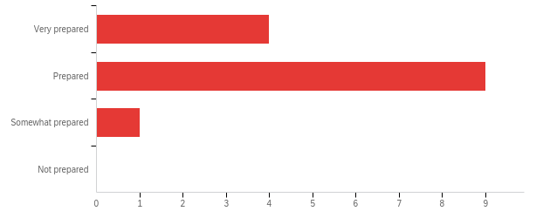
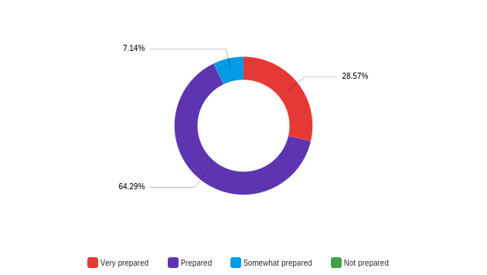

# | Answer | % | Count
1 | Very prepared | 28.57% | 4
2 | Prepared | 64.29% | 9
3 | Somewhat prepared | 7.14% | 1
4 | Not prepared | 0.00% | 0
 | Total | 100% | 14

Q2 - How prepared were the UNO graduates in their ability to manage classroom procedures?
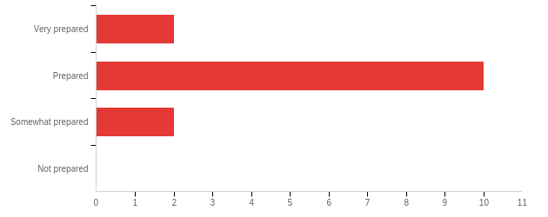
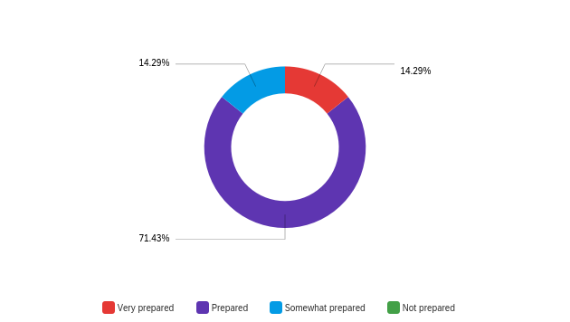

# | Answer | % | Count
1 | Very prepared | 14.29% | 2
2 | Prepared | 71.43% | 10
3 | Somewhat prepared | 14.29% | 2
4 | Not prepared | 0.00% | 0
 | Total | 100% | 14

Q3 - How prepared were the UNO graduates in their ability to use questioning, prompts, and discussion?
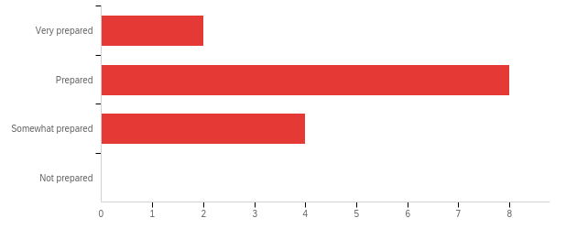
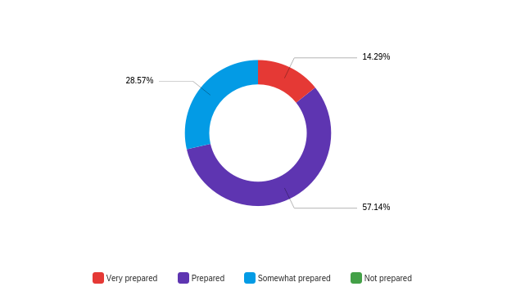

# | Answer | % | Count
1 | Very prepared | 14.29% | 2
2 | Prepared | 57.14% | 8
3 | Somewhat prepared | 28.57% | 4
4 | Not prepared | 0.00% | 0
 | Total | 100% | 14

Q4 - How prepared were the UNO graduates in their ability to engage students in learning?

# | Answer | % | Count
1 | Very prepared | 14.29% | 2
2 | Prepared | 71.43% | 10
3 | Somewhat prepared | 14.29% | 2
4 | Not prepared | 0.00% | 0
 | Total | 100% | 14

Q5 - How prepared were the UNO graduates in their ability to use assessment in instruction?
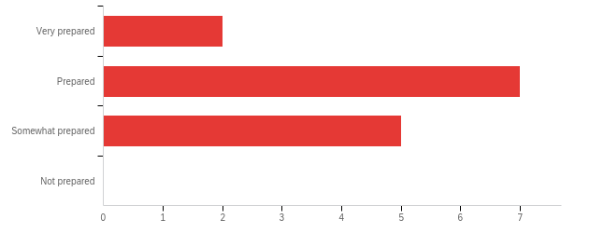
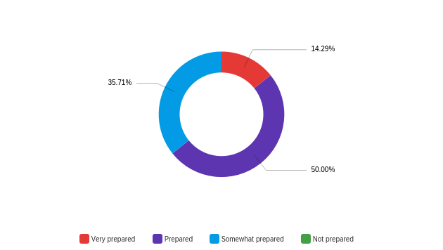

# | Answer | % | Count
1 | Very prepared | 14.29% | 2
2 | Prepared | 50.00% | 7
3 | Somewhat prepared | 35.71% | 5
4 | Not prepared | 0.00% | 0
 | Total | 100% | 14

Q6 - Overall how satisfied are you with the performance of the UNO graduates employed in your school?
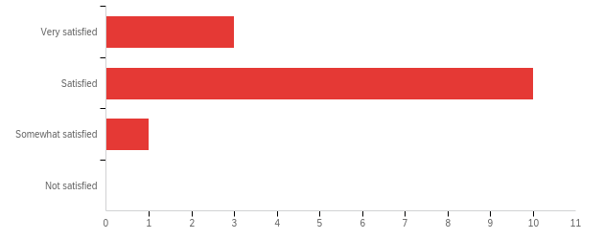
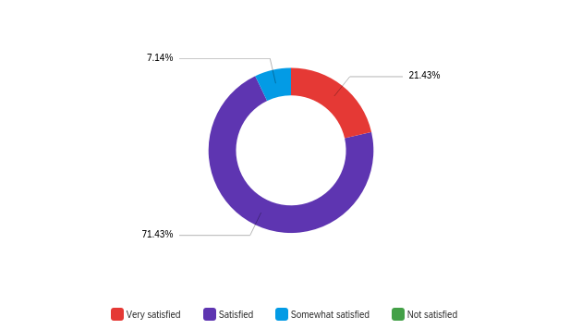

# | Answer | % | Count
1 | Very satisfied | 21.43% | 3
2 | Satisfied | 71.43% | 10
3 | Somewhat satisfied | 7.14% | 1
4 | Not satisfied | 0.00% | 0
 | Total | 100% | 14

Q7 - Overall, how satisfied are you with the professionalism and communication skills of the UNO graduates in your school?
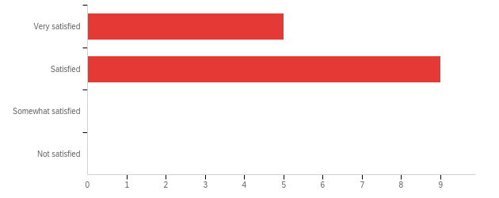
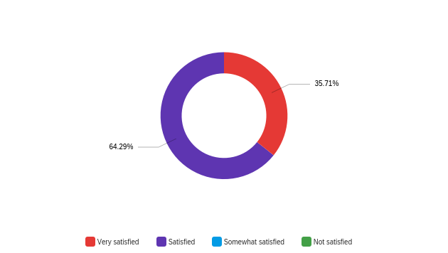

# | Answer | % | Count
1 | Very satisfied | 35.71% | 5
2 | Satisfied | 64.29% | 9
3 | Somewhat satisfied | 0.00% | 0
4 | Not satisfied | 0.00% | 0
 | Total | 100% | 14

Q13 - Please identify specific strengths of the UNO graduates.

Please identify specific strengths of the UNO graduates.
Curriculum Implementation
The student teaching program is a strength.
UNO graduates are hard-workers and are great with technology. They incorporate various techniques in their lesson planning and delivery. It is apparent that professors at UNO work diligently with students on professionalism.
Content Knowledge
Collaboration and Hard Working
Lesson Planning
They work with the school community to unhold and ensure high learner expectations.
Motivating Students/Classroom Management
Teachers are prepared well to present instructional content.

Q14 - Please identify specific areas for growth, of the UNO graduates, for future professional development.

Please identify specific areas for growth, of the UNO graduates, for future professional development.
Engagement to minimize classroom disruption
Focus on data driven instruction and inclusion of both ELLs and Sped students.
The demographics of Jefferson Parish are changing and I believe that the program should focus on ELL populations.
Classroom management techniques.
Classroom management
Consistent monitoring and immediate feedback provided to school counselors and administrators of student progress or lack thereof in order to remediate issues and avoid the potential of any troubling outcomes.
Questioning and Discussion Differentiation of Student Outcomes
Teachers could grow in their ability to use data to drive instruction (daily exit tickets) and their ability to provide academic feedback to students.

Q15 - Comments:

Comments:
Overall the UNO teachers perform well at Solis.

SC0 - Score

# | Field | Minimum | Maximum | Mean | Std Deviation | Variance | Count
1 | Score | 15.00 | 28.00 | 21.36 | 3.01 | 9.09 | 14

