Default Report
Completer Satisfaction Survey (2018-2019)
January 7th 2021, 11:27 am CST
Q3 - Degree
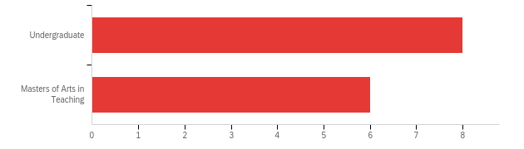

# | Field | Minimum | Maximum | Mean | Std Deviation | Variance | Count
1 | Degree | 1.00 | 2.00 | 1.43 | 0.49 | 0.24 | 14

# | Answer | % | Count
1 | Undergraduate | 57.14% | 8
2 | Masters of Arts in Teaching | 42.86% | 6
 | Total | 100% | 14

Q4 - Certification Area
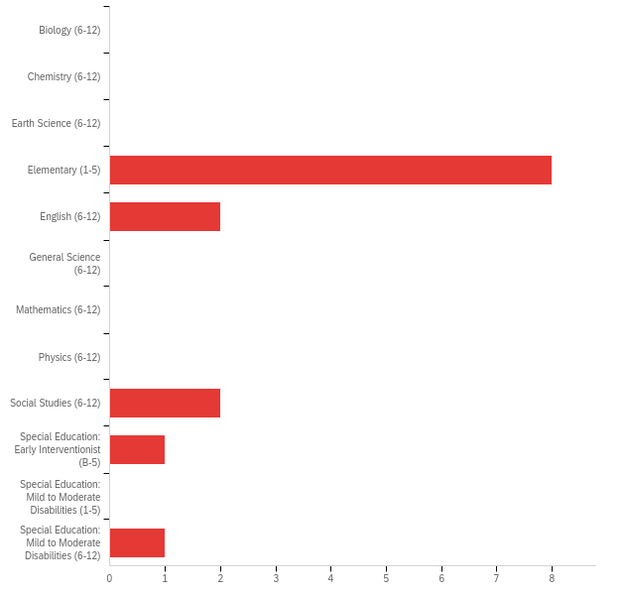

# | Answer | % | Count
1 | Biology (6-12) | 0.00% | 0
2 | Chemistry (6-12) | 0.00% | 0
3 | Earth Science (6-12) | 0.00% | 0
4 | Elementary (1-5) | 57.14% | 8
5 | English (6-12) | 14.29% | 2
6 | General Science (6-12) | 0.00% | 0
7 | Mathematics (6-12) | 0.00% | 0
8 | Physics (6-12) | 0.00% | 0
9 | Social Studies (6-12) | 14.29% | 2
10 | Special Education: Early Interventionist (B-5) | 7.14% | 1
11 | Special Education: Mild to Moderate Disabilities (1-5) | 0.00% | 0
12 | Special Education: Mild to Moderate Disabilities (6-12) | 7.14% | 1
 | Total | 100% | 14

Q5 - How closely related is your current position to your area of study at UNO?
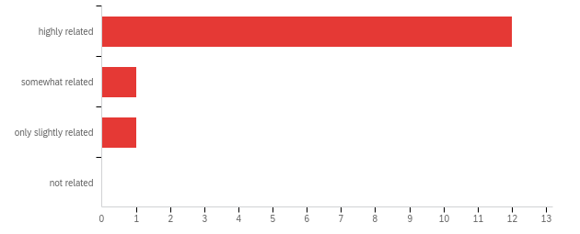

# | Answer | % | Count
1 | highly related | 85.71% | 12
2 | somewhat related | 7.14% | 1
3 | only slightly related | 7.14% | 1
4 | not related | 0.00% | 0
 | Total | 100% | 14

Q6 - If you are not currently employed in your area of study at UNO, indicate the reason:
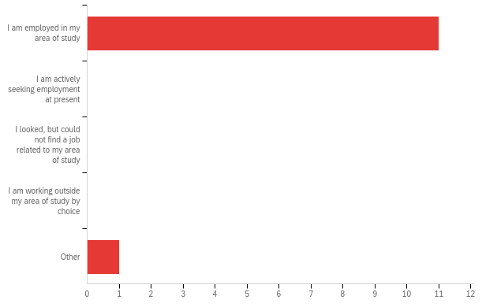

# | Answer | % | Count
1 | I am employed in my area of study | 91.67% | 11
2 | I am actively seeking employment at present | 0.00% | 0
3 | I looked, but could not find a job related to my area of study | 0.00% | 0
4 | I am working outside my area of study by choice | 0.00% | 0
5 | Other | 8.33% | 1
 | Total | 100% | 12

Q7 - How well prepared are you to create an environment that motivates students to learn?

# | Answer | % | Count
45 | Not Prepared | 0.00% | 0
46 | Prepared for Knowledge but not Practice | 14.29% | 2
47 | Prepared for students without special needs | 28.57% | 4
48 | Prepared for ALL students including students with special needs | 57.14% | 8
 | Total | 100% | 14

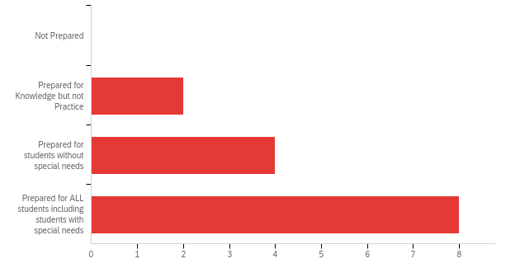
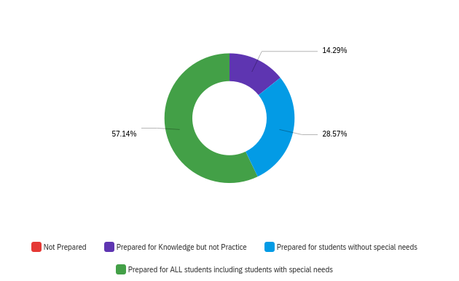

Q8 - How well prepared are you to manage classroom routines and the behavior of individual students?
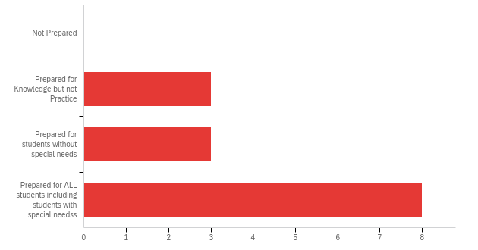

# | Answer | % | Count
9 | Not Prepared | 0.00% | 0
10 | Prepared for Knowledge but not Practice | 21.43% | 3
11 | Prepared for students without special needs | 21.43% | 3
12 | Prepared for ALL students including students with special needss | 57.14% | 8
 | Total | 100% | 14

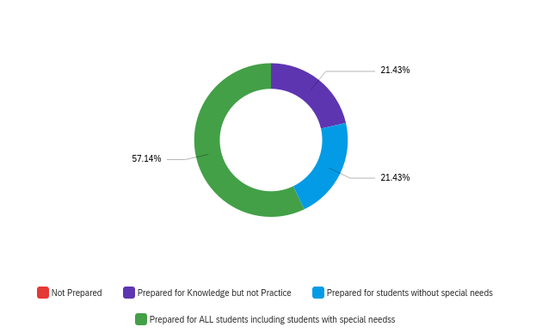

Q9 - How well prepared are you to plan and teach lessons that are aligned to curriculum goals and content standards?
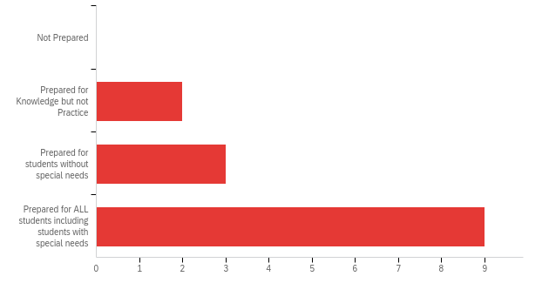

# | Answer | % | Count
9 | Not Prepared | 0.00% | 0
10 | Prepared for Knowledge but not Practice | 14.29% | 2
11 | Prepared for students without special needs | 21.43% | 3
12 | Prepared for ALL students including students with special needs | 64.29% | 9
 | Total | 100% | 14

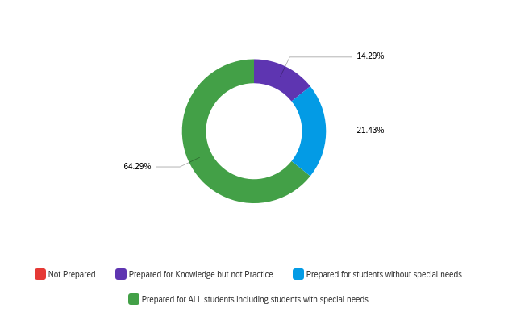

Q11 - How well prepared are you to make interdisciplinary connections?
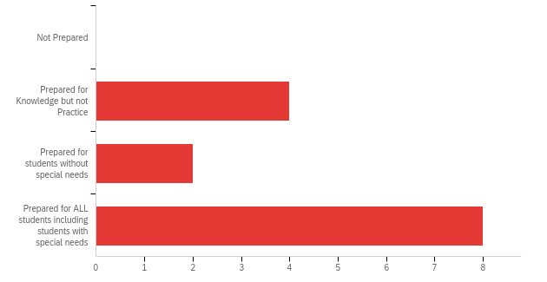

# | Answer | % | Count
9 | Not Prepared | 0.00% | 0
10 | Prepared for Knowledge but not Practice | 28.57% | 4
11 | Prepared for students without special needs | 14.29% | 2
12 | Prepared for ALL students including students with special needs | 57.14% | 8
 | Total | 100% | 14

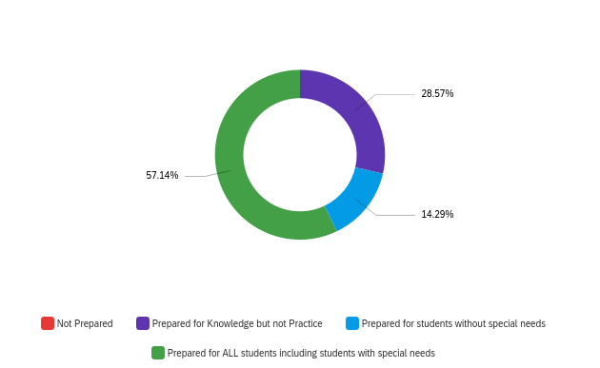

Q11 - How well prepared are you to use technology during instruction?
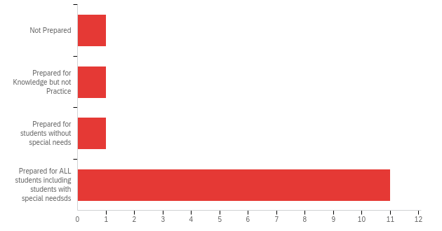

# | Answer | % | Count
9 | Not Prepared | 7.14% | 1
10 | Prepared for Knowledge but not Practice | 7.14% | 1
11 | Prepared for students without special needs | 7.14% | 1
12 | Prepared for ALL students including students with special needsds | 78.57% | 11
 | Total | 100% | 14

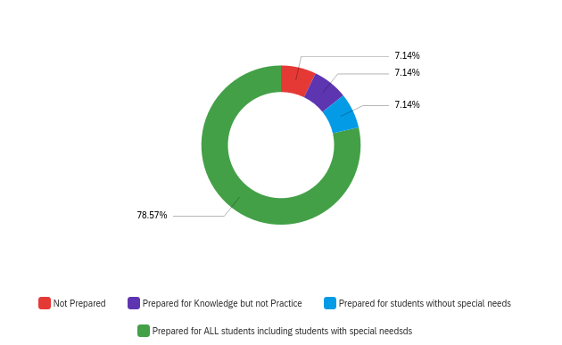

Q12 - How well prepared are you regarding content knowledge in your area?
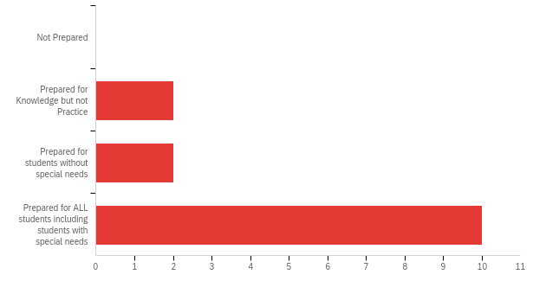

# | Answer | % | Count
9 | Not Prepared | 0.00% | 0
10 | Prepared for Knowledge but not Practice | 14.29% | 2
11 | Prepared for students without special needs | 14.29% | 2
12 | Prepared for ALL students including students with special needs | 71.43% | 10
 | Total | 100% | 14

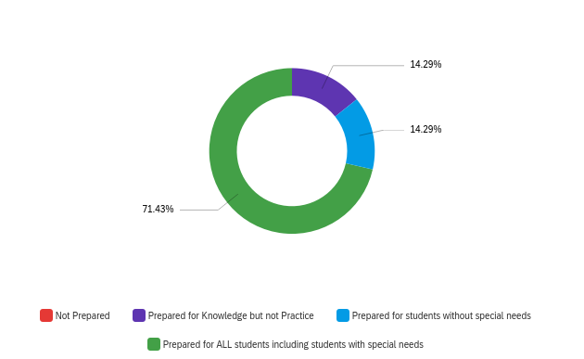

Q14 - How well prepared are you to implement varied activities and strategies?

# | Answer | % | Count
9 | Not Prepared | 0.00% | 0
10 | Prepared for Knowledge but not Practice | 14.29% | 2
11 | Prepared for students without special needs | 14.29% | 2
12 | Prepared for ALL students including students with special needs | 71.43% | 10
 | Total | 100% | 14

Q14 - How well prepared are you to collect, analyze, and use assessment data for lesson planning?
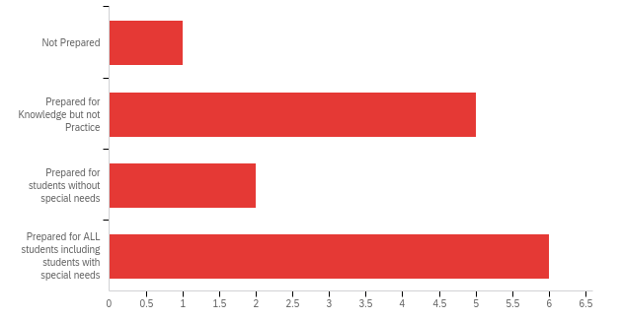

# | Answer | % | Count
9 | Not Prepared | 7.14% | 1
10 | Prepared for Knowledge but not Practice | 35.71% | 5
11 | Prepared for students without special needs | 14.29% | 2
12 | Prepared for ALL students including students with special needs | 42.86% | 6
 | Total | 100% | 14

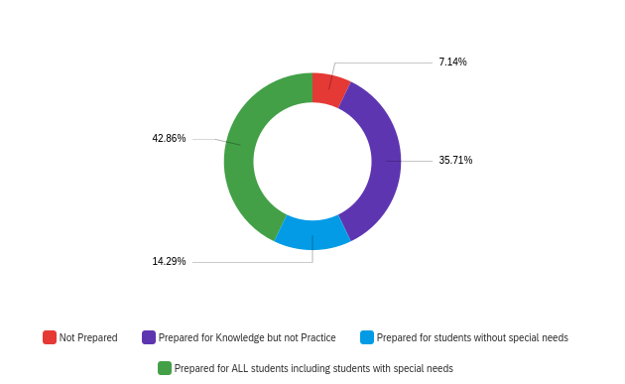

Q15 - How well prepared are you to advocate, model, and teach ethical behavior?
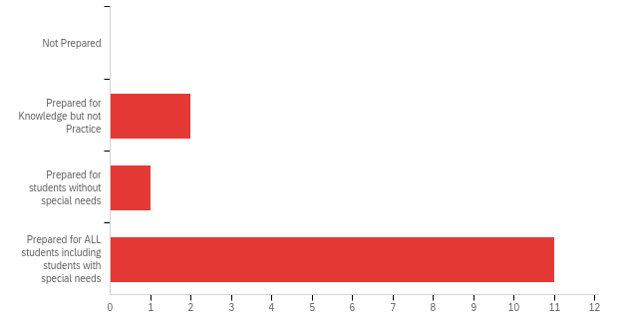

# | Answer | % | Count
9 | Not Prepared | 0.00% | 0
10 | Prepared for Knowledge but not Practice | 14.29% | 2
11 | Prepared for students without special needs | 7.14% | 1
12 | Prepared for ALL students including students with special needs | 78.57% | 11
 | Total | 100% | 14

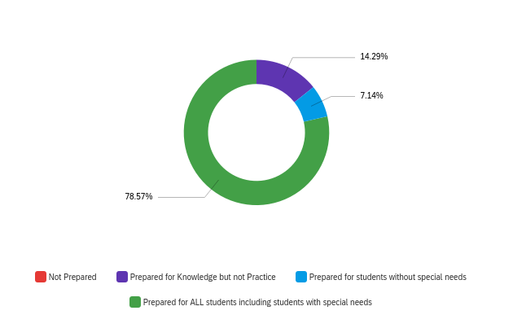

Q17 - How well prepared are you to be culturally responsive in the classroom?
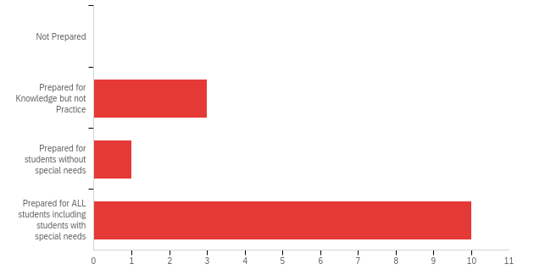

# | Answer | % | Count
9 | Not Prepared | 0.00% | 0
10 | Prepared for Knowledge but not Practice | 21.43% | 3
11 | Prepared for students without special needs | 7.14% | 1
12 | Prepared for ALL students including students with special needs | 71.43% | 10
 | Total | 100% | 14

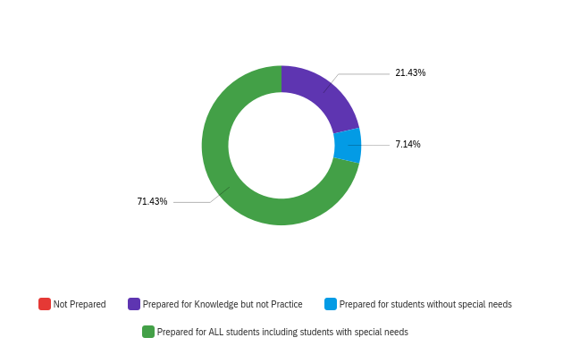

Q17 - What aspects of the program do you think were most valuable?

What aspects of the program do you think were most valuable?
I think it was very valuable to get to observe teachers from schools that I could choose so that I could experience a variety of teachers at a variety of different types of schools. This helped me to decide what kinds of schools I wanted to apply to after I graduated.
The methods course.
Student teaching is essential. Education courses are great in theory but do little for real preparation.
These were the classes that taught specific elementary level content, such as our methods courses.
The professors and my fellow classmates were absolutely the most valuable thing about attending UNO. To this day, some of my closest friends are people who I met in classes at UNO. My professors were always encouraging, kind and open about deadlines and other classroom rules/necessities. The professors and administrators in the education department were also extremely accommodating, as I was teaching during my last semester and were always willing to stay late, or come early, depending on what worked with my teaching schedule. I am forever grateful to all my professors!
Student teaching
Observing students at so many different schools helps with the fact that students come from different backgrounds, socioeconomically. It helps to give each student what they need individually to grow and learn.
All of the teachers and classes helped to better prepare me and shape me as a teacher. I have been thankful for my time at UNO which taught me first and foremost the art of flexibility. Being willing and able to understand that things continuously change, has given me an attitude in the classroom that purposefully allows for that change. I am generally pretty easy going and willing to adapt to whatever is thrown my way. I am currently teaching middle school science. Originally, I was a secondary major with a focus in chemistry, so it’s the perfect fit for me! I have enough science credits to be certified within the classroom for science.
All

Q18 - What suggestions would you offer to improve the program?

What suggestions would you offer to improve the program?
Check the spelling of this survey - it’s embarrassing.
Fewer college level content courses and more courses that prepare future elementary educators for the content levels they may be teaching
I don’t see why the Science classes are necessary. We teach Science for a short period of time in the classroom for one of the 9 weeks and that’s it.
I think the thing I was least prepared for was how to accurately use data from different platforms to guide my teaching. I also was not prepared for interactions with parents.
I would suggest a little more communication from the advising standpoint. I ended up leaning a lot on my mentor professor, Dr. Nuccio, for questions about my degree as my advisor kept on changing and was not as available as other professors. I would maybe suggest having an advisor specifically for graduate school students, so they have that specific knowledge.
I would suggest letting student teachers spend half of their time with one mentor and the other half with another mentor. I think this would allow them to experience two different ways that these teachers implement the things that the student has learned about at UNO. I think there should also be more courses about how to teach students with special needs, even if you aren't majoring in Special Education. I felt like I was only a little prepared for how to modify my lessons for students with special needs, but it would have been more helpful if I had more of an opportunity to learn skills to modify my lessons.
None that I can think of. It was a wonderful experience.
Technology in the classroom. This wasn't a thing when I was on school but teacher google classroom
There should be more focus on technology: creating materials for the digital world, virtual teaching, and assessing skills without being in person. An elementary graphic design class would be helpful for new teachers.

SC0 - Score

# | Field | Minimum | Maximum | Mean | Std Deviation | Variance | Count
1 | Score | 23.00 | 44.00 | 38.14 | 6.57 | 43.12 | 14

