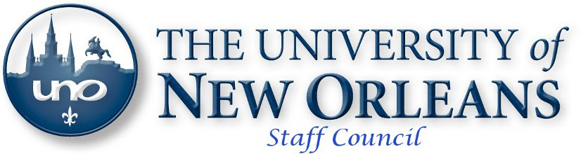

January 16, 2014 - Minutes
Library 407, 10:00AM

- Call to Order

- Executive Committee Reports
  - President – Derek Rodriguez
    - No report
  - Vice-President, Brian McDonald
    - Staff Council website now has Feed Back button
      - Comments are anonymous and will email the Staff Council website
  - Treasurer, Amanda Green
    - Account balances:
      - General Fund Balance is shown as $2,697. We have committed $1,947.90 to ARAMARK for the Spring Staff Appreciation Event. “Available” balance is $749.10.
      - Credit Union Savings Account balance is $6.94.
      - Scholarship Activity Fund (Foundation): $966 available to give as Scholarships
    - Holding 8 bookstore $250 gift cards from Follett totaling $2,000
  - Recording Secretary, Carol Lunn
    - Minutes were submitted
    - Due to budget this is the last meeting with refreshments
  - Corresponding Secretary, Charlann Kable

- Committee Reports
  - Events Committee – Harold Bauer, Chair
    - Food drive - collected 1,500 pounds of food which was a new record
    - Spring Fling – the room, menu and other items are all set up; still seeking auction items
  - Awards Committee – Brian McDonald spoke for the chair
    - The bookstore gift cards can be given out till the summer
    - Working on updating scholarships and plan to send something out after enrollment ends
  - Member/Elections – Brian McDonald
    - Will have updated By-laws out soon
  - ad hoc By-Laws Committee –

- New Business
  - By-Laws Discussion
  - Ad hoc Property/ Inventory Swap Committee
    - Inventory Swap ad hoc Committee - Create some way we can advertise to departments when there is property available at UNO instead of sending to Baton Rouge. Example: An office is turned into a lab and the furniture is no longer needed. The furniture currently goes to property control who has little storage and has to surplus to Baton Rouge. A short while later the same item may be purchased by another department because they were unaware that it was available on campus.
      - I spoke to Elizabeth Bourgeois, Director of Internal Audit, about surplus property on UNO’s campus.
        - Ms. Bourgeois does not believe it would be a problem to internally advertise surplus property on campus, in an effort to have other UNO units acquire it.
        - This is something which the cost containment committee may be able to recommend, or Staff Council may want to participate in setting up a system to communicate with the campus (i.e. a SharePoint site).
      - We are requesting volunteers for an ad hoc committee to work with Property Control to create a SharePoint system for seekers and donors of property/supplies.
      - Please contact Brian if you are willing to volunteer on this ad hoc committee. Marilyn Hayden, John Theriot and Harold Bauer volunteered to serve
      - A member of the audience requested a link to property control and completed swap site be added to the faculty/staff resource page on UNO website
    - We had a question submitted asking if UNO can do something with scrap other than throw it away. (Example: you rewire an office. The wiring has copper in it. Can that be sold and the funds be given to UNO?)
      - I spoke to Roy Robertson, Manager of Property Control, and we are not allowed to sell scrap and keep the money for ourselves. We can sell scrap but the money has to go to LPAA.
        - However, the contract can be written for the contractor to scrap non-moveable property for a reduction in price.
        - Again, this only pertains to non-moveable property. Examples of non-moveable property are: wiring, mounted cabinets, mounted counter tops and sinks.
      - This information was passed on to Bill Sheffield in the UCC who can use it on future projects.
        - Maybe the ad hoc committee could determine who else needs to know this information and how it can be codified as a requirement for future contracts?
        - The cost containment and revitalization committee could also address at a later date.
    - Dr. Lassen agreed that if it is recommended that additional space is needed to store items for a swap, he would be willing to discuss.

- Guest Speaker - Vice President Lassen
  - Cost Containment and Revitalization Committee is meeting to make recommendations to President Fos regarding ways to manage the budget shortfall and create an opportunity to improve operations going forward
  - Due to state budget cuts universities across the nation are going through similar exercises
  - UNO needs to right size so that we are more aligned with the current size of the student body; however, we need to reorganize strategically so we are still positioned to be able to grow
  - Very few firm decisions have been made
  - UNO is ranked 8 of 9 in financial stability in the UL System so there is pressure to act quickly
  - Five years ago Louisiana changed the funding model so we are now competing for funding with other schools rather than having an allocation model
  - Questions from audience
    - What is the time line for the CCC to make their recommendation?
      - The cuts need to come soon; the revitalization will take time; Some of the bonds UNO has require a reserve and UNO has been living on savings for so long cuts have to be made now because the savings are almost depleted
    - Where is the money coming from to convert the Children’s Center to an international center?
      - Local foundation dedicated funds to UNO Foundation for International Studies
    - Is the strategic plan being used for the cuts?
      - Yes. We are looking at what areas are making money or can grow to improve UNO.
    - Are we rebranding/licensing and selling merchandise? There was some talk of having UNO items for sale in local stores.
      - Improvements have been made in those areas
      - The new Athletic logo won an award
      - Bed Bath & Beyond at Clearview has a UNO section
      - Walgreens on Elysian Fields has a UNO section in the back

- Next Meeting – February 20, 2014

- Adjournment

- Door Prizes

Staff Council is dedicated to providing the best possible representation for the staff of the university. Our goal is to identify ways to support and enhance the lives of our valued
fellow staff. Staff Council welcomes input from the entire university community in
order to make the University of New Orleans the best place in the City of New Orleans
and the state of Louisiana to work and prosper.

