April 24, 2014
Library 407, 10:00AM

- Call to Order

- Executive Committee Reports
  - President, Derek Rodriguez - absent
  - Vice-President, Brian McDonald
    - HR is bringing back the employee recognition program
      - Announcements should go to campus soon
    - Employee training page online
      - HR will launch in May
  - Treasurer, Amanda Green
    - General fund – while there is over $700 remaining, no more funds will be spent due to the spending freeze
    - Credit union – proceeds from the Spring Fling are still in the credit union; they will be moved to the foundation when the final collection is received for an auction item
    - Foundation spending account – there is $966 in the account but the staff council award of $500 should be given out soon and will reduce that amount
  - Recording Secretary, Carol Lunn
    - As a reminder – minutes are posted on SharePoint as they are completed
    - If you want to review the minutes and they are not on the website, please check SharePoint
    - Each month has its own folder which contains the agenda, minutes, sign in sheets and documents covered in that month’s meeting
    - When Staff Council uses PowerPoint, or when guest speakers review reports, documents are requested. If the documents are provided they are posted on SharePoint with the minutes.
  - Corresponding Secretary, Charlann Kable
    - Will post approved bylaws after today’s meeting

- Committee Reports
  - Events Committee – no report
  - Awards Committee
    - Vote on how to award the 8 bookstore gift cards of $250 each
    - Proposed distribution:
      - 1 to Staff council scholarship recipient this year
      - 1 to Staff council scholarship recipient next year
      - 1 to Staff council scholarship runner up this year
      - 1 to Staff council scholarship runner up next year
      - Staff employee of the year
      - Summer award
      - Fund raiser award
      - Spirit award
        - PASSED BY MAJORITY VOTE
  - Membership/Elections Committee
    - Provided ballots to vote on staff council representatives
    - Provided nomination forms for officers – vote next month
  - Bylaws Committee – Voting Results by Brian McDonald
    - The final comments submitted in last month’s meeting were incorporated and the final draft sent for voting
    - There were 14 yea and 0 nay votes
    - The updated bylaws are approved and final
    - Charlann will post online after today’s meeting

- New Business
  - Accept Final Nominations for Staff Council Representatives and Vote
  - Spirit Fridays – presented by Carol Lunn
    - Dr. Lassen requested Staff Council assistance in creating Spirit Fridays; the executive committee met to brain storm some ideas:
    - Kick Off Day
      - In between UC and Rec Center
      - Ask people to wear silver/blue/UNO logo
    - Good News Friday
      - Administration and/or Staff Council can blast campus with accomplishment, event, etc.
    - Involve Credit Union
      - Participate with giveaway or spin the wheel
    - Dress down Fridays
      - If wear silver, blue or UNO logo item
    - Office Spirit Prize
      - Office can submit pictures showing Friday Spirit day
      - Office with most votes wins Office Spirit Day Certificate
      - At year end office with most certificates wins catered office party
    - Spirit Projects
      - Planting Day; Clean a building day; Other projects to improve campus life
    - PASSED BY MAJORITY VOTE
      - Will be sent to event committee to implement
      - Audience suggested that the event committee may want to see if they can work with the student group that is promoting wearing blue on Tuesdays
      - Several staff members said they may be able to dress down on Friday but most agreed they could not dress down on Tuesday

  - Update on Development of Smoke Free Policies (Act 211) – presented by LaJana Paige
    - Committee has reviewed local and national school policies to ensure our policy meets benchmarks
    - E-Cigs
      - Included in most other policies reviewed
      - FDA recently issued guidance – committee will review and use in developing policy
      - Students want to have a referendum to keep e-cigs out of UNO policy
    - August 1, 2014 – UNO will be a tobacco free campus
  - Announcement of Staff Council Representatives (records posted in SharePoint with minutes)
    - These are the individuals who will eligible to vote in next month’s elections for officers
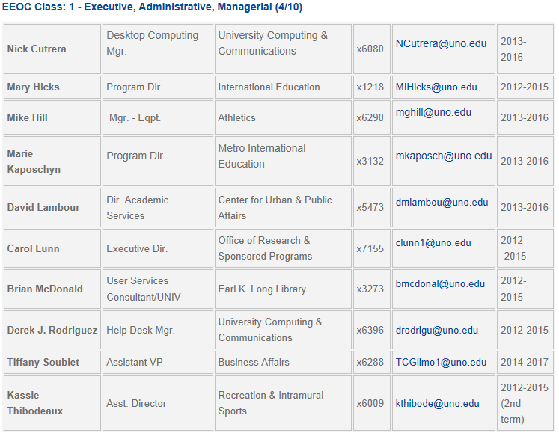
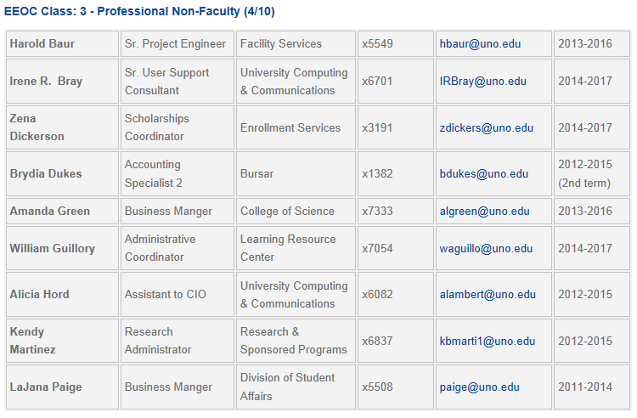
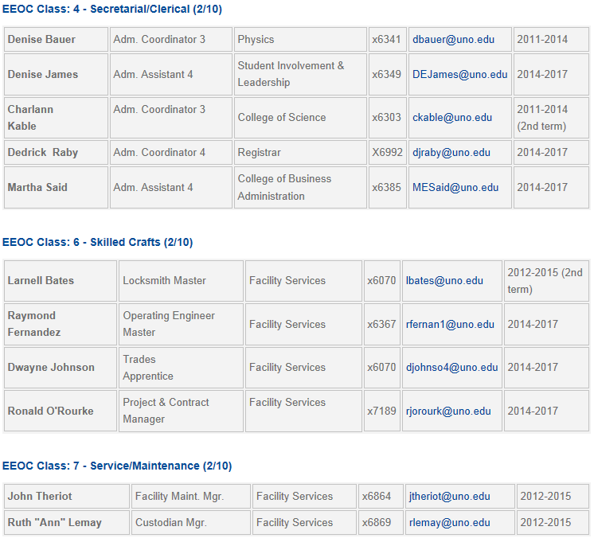

  - Nominations for Staff Council Officers
    - Nomination forms were handed out – an email will also be sent to staff
    - Officers must be nominated prior to next month’s meeting

- Next Meeting – May 15, 2014 (Election of Staff Council Officers)

- Adjournment

Staff Council is dedicated to providing the best possible representation for the staff of the university. Our goal is to identify ways to support and enhance the lives of our valued
fellow staff. Staff Council welcomes input from the entire university community in
order to make the University of New Orleans the best place in the City of New Orleans
and the state of Louisiana to work and prosper.

