ORSP TRAVEL GRANTS FOR TENURED FACULTY TO VISIT PROGRAM MANAGERS
(Based on BoR Travel Grants for Emerging Faculty)

Request for Applications

DEADLINE DATES:
Open deadline until: June 30, 2015

Issuance Date: January 1, 2012
Previous Revision: None
Notice – As this Request for Applications may undergo revisions please check our web site at http://www.uno.edu/orsp/ORSPHome/FundingOpportunities to verify that this version is the most up-to-date.

A. Program Overview
Faculty members, who hold a regular tenured position at UNO, are eligible for an award.

Each application must include: 1) travel justification, 2) a letter of support from the applicant’s chairperson and/or dean, 3) curriculum vita, and 4) budget with budget justification. Travel advances will not be made; awarded funds will be disbursed only after the traveler submits documents, which demonstrate that the objective of the proposed travel was achieved. Expenses in excess of the award amount and/or expenses that are not in accordance with State travel regulations, even if less than the allotted limit, are the responsibility of the traveler.

B. General Information
B.1 Program Purpose
The purpose of the program is to help UNO’s faculty researchers become more competitive. This is accomplished by providing eligible faculty with an opportunity to visit federal agency program officers and learn how to better structure a research proposal(s) to be more competitive in the peer review process

B.2 Requirements for Consideration/Definitions

Meetings with federal funding agency program officers are required to take place at the agency office, as this allows for longer, more productive meetings and additional opportunities for interaction with agency representatives. Travel to conferences or workshops at which federal agency program officers are present will not be considered.

B.3 Award Amounts
The maximum amount available to an awardee traveling to visit a funding agency is $2,000.

B.4 Eligible Faculty
Individuals who hold a regular tenured position at UNO are eligible for an award. In general, no more than one application per calendar year will be awarded to an individual.

C. Application Format
C.1 Travel Justification
Applications must use an ORSP Routing Form, which requires a comprehensive abstract (200 words or less) of the applicant’s research program, the name of the agency and officer within that agency that the researcher plans to visit and a synopsis of an anticipated proposal submission.

Applications must also include correspondence (email will suffice) from the program officer(s) that the applicant will be visiting.

C.2 Department/College Endorsement
Applications must include a letter from the applicant’s chair and/or dean that indicates his/her support for the proposed travel. The letter of support must also document the department/college/institution investment in the applicant’s research program and certify the credentials and tenured status of the traveler.

C.3 Curriculum Vita
The curriculum vita, in UNO format, of the faculty member must be attached to the application.

D. Submission of Applications

D.1 Grant Period
The period covered by this Program RFA is the issuance date through June 30, 2015. Applications will be accepted throughout this period, contingent upon availability of funds.

D.2 Timing of Applications
Hard copy applications will not be accepted.

The proposal must be submitted to the Office of Research and Sponsored Programs electronically on a Routing Form in SharePoint. Electronic signature by the chair and dean will denote approval of the proposal and acceptance of the requirements of this RFA. Routing Forms must be received in SharePoint at least thirty (30) days prior to the applicant’s anticipated date of travel in order to be reviewed before travel occurs. The applicant will be notified within those thirty days as to whether their application was approved. Applications for travel in the month submitted will not be processed; travel must occur within six months of the award date. Reimbursement for travel must follow normal university guidelines.

D.3 Electronic Submission

All submissions must be uploaded as a regular Routing Form in SharePoint.

Instructions for PIs:

- To denote this is an internal award please select the following options in section 2 of the routing form:

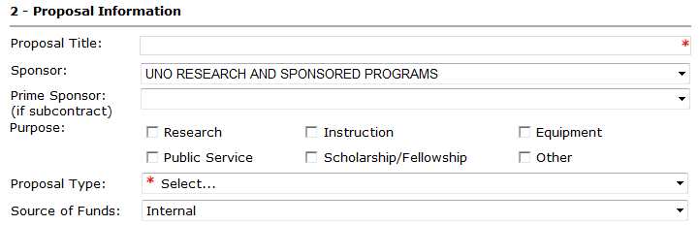

- Indirect Costs will not be charged since this is an internal award. Complete section 4 of the Routing Form as such:

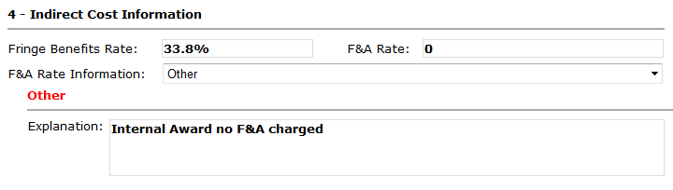

E. Evaluation
E.1 Application Submission
Applications to the program will be accepted, evaluated, and funded based on availability of resources. All applications will be reviewed by the Research Council and the Vice President for Research and Sponsored Programs (or their designee) and applicants will be notified within approximately thirty (30) days as to whether their application has been approved.

E.2 Post-award
The objective of the program is to increase the competitiveness of UNO’s faculty researchers. To document successes and justify continuing support for the program, participants are required to complete a questionnaire shortly after the completion of their travel to determine if the investment generated positive results. The questionnaire will address the name and contact information of the program manager and any useful information obtained from the visit. Submission of an application and acceptance of an award commits the individual awardee to fully comply with this requirement. Once this information is provided, the awardee’s responsibilities are fulfilled.

F. Award Conditions
F.1 Change Requires Approval
Prior written approval from the Vice President for Research and Sponsored Programs or his/her designated representative is required for any change in travel plans, such as substituting an agency and/or officer other than the one specified in the original travel plan. Unauthorized changes will, without exception, be deemed in violation of the conditions of the award and nullify the agreement.

F.2 Travel Reimbursement
Travel reimbursement requests must be submitted to the Office of Research and Sponsored Programs (Attn: Travel Program) within 30 days of completion of travel; funds that are not claimed within 30 days will revert to the pool of money available for the travel program.

Awardees must submit a Travel Expense Account Form along with the originals of all travel receipts/documents as required for normal state-supported travel. The completed travel expense account form and university required attachments will be approved in the department and sent to ORSP for a speed key. Awardees will be reimbursed for expenses that qualify under the State travel regulations. Expenses in excess of the award amount and/or expenses that are not in accordance with State travel regulations, even if less than the allotted limit, are the responsibility of the traveler. The funds will be released upon receipt of a completed Travel Expense Account Form and questionnaire.

In accordance with state travel guidelines, all commercial airfare tickets must be purchased from the state contracted travel agency. This requirement is mandatory unless approval is granted from the State Travel Office.

G. Additional Information
Please direct questions to: Carol Lunn
Executive Director
Office of Research and Sponsored Programs
280-7155 (Phone)
clunn1@uno.edu

H. Attachments
A. Check List
B. Evaluation Form
C. Follow-up Questionnaire
Attachment A
Check List

Travel Grants for Tenured Faculty

- Submit Routing Form in SharePoint

- Travel Justification. Describe your research program (200 words or less), agency and program officer(s) you will visit, and a synopsis of the proposal you anticipate submitting.

- Provide correspondence from the program officer(s) you will be visiting.

- Chair or Dean Endorsement. Attach a brief letter from your Department Chair and/or Dean indicating their support for the proposed travel. This statement should describe the department/unit/institution investment in your research program.

- Curriculum Vita. Attach a curriculum vita that includes a complete list of publications, all contributed and invited talks, student (M.S. and Ph.D.) production record, and submitted and funded proposals.

- Budget and Budget Justification. Attach a budget and budget justification using the budget template embedded in the electronic Routing Form.

- Acceptance of Program Requirements. By submitting the Routing Form, PI’s agree that they have read and understand the program requirements detailed in this RFA, particularly Sections E-G dealing with Award Conditions, Reporting Requirements, and Post-Award Evaluation. If awarded faculty agree to ensure timely compliance to all program requirements.

Travel Grants for Tenured Faculty

Attachment B

REVIEWER EVALUATION FORM - TRAVEL GRANTS FOR TENURED FACULTY

Applicant’s Name:

_____________________________________________________________________________
Last First M.I.

Title: ______________________________________ e-mail ______________________@uno.edu

BASIC REQUIREMENTS
The applicant holds a regular tenured science and engineering. The application:
Meets or exceeds basic requirements: ______ (proceed with the evaluation)
Does not meet the basic requirements: ______ (stop here, give explanation)

Comments: ___________________________________________________________________________________

1. (40 %) Travel justification — Applicant is required to provide: (A) an abstract (200 words or less) of research program, name of the agency and officer to visit, and a synopsis of an anticipated proposal submission and correspondence from the program officer(s) that the applicant will be visiting. How do you rate the applicant’s response to this requirement?
Excellent _____ Very Good _____ Good _____ Average _____ Fair _____ Poor _____

2. (30 %) Department/College endorsement — The application is to include a brief statement from the applicant’s Chair and/or Dean indicating support for the proposed travel and describing departmental/college/institutional investment in the applicant’s research program. Please rate this endorsement.
Excellent _____ Very Good _____ Good _____ Average _____ Fair _____ Poor _____

3. (30 %) Curriculum vita — A curriculum vita must be attached. It should include a complete list of publications, contributed and invited talks, student (M.S. and Ph.D.) production record, and funding history, including submitted and funded proposals. Based on this information, how do you rate the applicant’s funding potential?
Excellent _____ Very Good _____ Good _____ Average _____ Fair _____ Poor _____

Reviewer’s overall recommendation: Support _____ Additional Justification* _____ Do Not Support _____

*Brief explanation: _____________________________________________________________________________

____________________________________________________________________________________________

Reviewer’s Signature: ___________________________________________________ Date: __________________

Attachment C
Travel Grants for Tenured Faculty Follow-up Questionnaire
(To be completed after travel)

Failure of an awardee to comply with this requirement will result in declination of future UNO ORSP awards to that individual until such time as the delinquent report is received.

Name: ______________________________________________________________________ Last First M.I.

Title: ________________________________________________

Department: How did you learn of the program?

______________________________ _____ ORSP _____ Chair

_____ Colleague
_____ Other:__________________
Grant Purpose:

Proposal Title: _____________________________________________________________

Submission Date: ___________________ Was your proposal funded? Yes/No/Not yet

With whom did you meet?

____________________________________________________________________________
Name Title Organization

The response to your proposal: ____ Favorable ____ Unfavorable ____ Noncommittal

Was the meeting beneficial to preparing your proposal? ____ Yes ____ No

Is follow-up contact planned? ____ Yes ____ No If yes, explain: _____________________

____________________________________________________________________________

Suggestions for changing/improving the program:_______________________________

____________________________________________________________________________

____________________________________________________________________________

Additional Comments: __________________________________________________________

____________________________________________________________________________

____________________________________________________________________________

